**Effects of shell condition and temperature on the size-weight relationships of three major Alaskan commercially fished crab stocks and derived biomass estimates**

Jonathan I. Richar and Michael A. Litzow

**Abstract**

The modeled length-weight relationship is a critical component in expanding survey-derived data to create population estimates for eastern Bering Sea crab stocks. Current procedures assume this relationship to be constant across a range of both crab physiological parameters, and environmental conditions for the purpose of creating biomass estimates. We assessed effects of shell condition on length-weight relationships for Bristol Bay red king crab, and eastern Bering Sea opilio and Bairdi crab, and environmental temperature on that for Bristol Bay red king crab. Population biomass estimates were derived using calculated model parameters, and compared to estimates calculated using the current fixed parameters. Old shell crab were found to be heavier for a given size in all models, with some variability in the slope of the size-weight relationship across sizes. New shell red king crab were found to weigh less for a given size in cold years. Relative to estimates calculated using the current standard models for these stocks population biomass estimates were modestly larger with some interannual variability. These results suggest that current biomass estimation procedures used in stock assessment require reconsideration and updates.

**Introduction**

Red king crab, southern tanner crab and snow crab form the basis of economically valuable fisheries in the eastern Bering Sea (EBS). An important component of effective fishery management for these stocks is the calculation of biomass estimates based on size frequencies through the use of size-weight models based on a subset of the survey catch. The current model implementations used to generate estimates for these stocks assume a constant relationship across a range of environmental conditions and crab ages post molt, with the only allowances for variability being sex and maturity status-specific models (Zacher et. al 2020).

Individual crab weights may however be influenced by factors beyond the size of the given individual. Crabs which have not molted recently are likely to have communities of encrusting organisms growing on their carapace, including hydroids, barnacles and tunicates. Although efforts are made to either exclude such crab from being weighed altogether or remove these epibionts prior to sampling, it may not always be possible to successfully remove all of them. In such cases, the affected crab are likely to weigh more than individuals with clean carapaces due to the additional mass of these organisms. Because epibionts are a factor considered when distinguishing between new shell (NS) and old shell (OS) crabs, OS crabs, which usually have a much more epibiont growth, are likely to be more affected than NS crab, which typically have little or none (Jadamec 1999).

The length-weight relationship is also likely to be influenced by relative meat fill (i.e. the amount of soft tissue) within the crab’s carapace, which is itself influenced by both the time elapsed since last molt, and the crab’s condition. Because OS crab will have had more time for tissues to develop since their last molt, it is likely that they will have greater meat fill than their NS counterparts. Importantly, temperature can influence both individual condition and time elapsed since last molt by altering molt intervals (Chilton et al. 2010; Stevens 1990), and thermally stressing the given crab (Azra et al. 2020). Consequently, a crab’s environment may also influence the length-weight relationship, particularly when the crab is sampled under rigid, standardized procedures, such that crab in a given area will be sampled at the same time every year.

Finally, a crab’s size-weight relationship is likely to be influenced, albeit to a lesser degree, by mineralization of the carapace. This is related to the time elapsed post-molt; increasing with time to a certain point, then declining as the crab approaches the graveyard stage and senescence. Old shell (SC3) crabs are likely to have the most mineralized and densest carapace structure, while new shell (SC2) and very old shell/grave yard (SC4/5) crabs will have comparatively less mineralized and less dense carapaces; the former due to limited time to mineralize post-molt, the latter due to age-related deterioration and shell disease.

In the work presented here, length-weight relationships are modeled based on shell condition (SC) for male Bristol Bay red king crab (BBRKC), and both male and female EBS *Chionoecetes bairdi* (EBS CB) and *Chionoecetes opilio* (EBS CO) crabs. These models are then used to assess the degree to which the use of SC specific size weight models alters population biomass estimates that are used in the assessment of these stocks. Finally, the effects of temperature on the length-weight relationship in new shell male and female Bristol Bay red king crab are also investigated.

**Methods**

Data for BBRKC, EBS CB and EBS CO were used to develop size-weight models. Male and female crabs were sampled during summer bottom trawl surveys conducted by the Alaska Fisheries Science Center during June-August in the years 2000-2019, though there were inconsistencies in sampling effort, and weights were not taken during all years in this series (Table 1). Individual length/width is currently measured to the nearest 0.1mm using digital calipers; prior to 2015 measurements were taken using Vernier calipers. In addition, prior to 2006, measurements were taken to the nearest 1 mm only. Weights were measured to the nearest 2 g via digital scale. Shell condition, which is used as an index for time elapsed since the most recent molt, and is based on carapace wear and epibiont accumulation, was classified as per standardized protocols (Jadamec 1999). For analysis purposes, SC2 males were categorized as NS, while SC3 and SC4 males were combined into an OS group. Very small sample sizes prevented consideration of SC4 males separately. Respective measurement sample sizes by species, SC, year and thermal regime of sampling year may be found in Table 1.

For analysis, the allometric size-weight relationship for each group may be modeled as

[1]

where *W* is the measured weight in g, *L* is the corresponding carapace size measurement (length/width) in mm, and *a* and *b* are model estimated parameters. This model was linearized via log-transformation as

[2] ,

which then permitted parameter estimation via linear modeling methodologies using the statistical software R ((R Development Core Team 2019). Initial models were tested for outliers, using Cook’s Distance, and any such data points were then removed prior to the fitting of final size-weight models. Using the final fitted models, Analysis of Covariance (ANCOVA) procedures were used to test for equality of the model size-weight relationships when compared between SC groups, and for BBRKC only, between thermal regime groups.

Because a final objective for this work was to develop size-weight models that may be applied for stock assessment purposes, for primary analyses all available data were employed to ensure that models were representative of all size classes sampled. Old shell males are however more prevalent at larger size classes, leading to a mismatch in size ranges represented in the data, which may drive model differences between new shell and old shell groups. To address this, for each stock, new shell males were subset into two secondary data series; the first with a size cutoff corresponding to the size of the smallest observed old shell males (BBRKC, >79 mm; EBS CB, >40 mm; EBS CO, > 36 mm), and the second with a cutoff corresponding to the lower boundary for upper 3 quartiles of old shell males (BBRKC, >132 mm; EBS CB, >106 mm; EBS CO, > 76 mm). Old shell male data were also subset as per this last cutoff to maximize comparative equivalency. These data were only used to test for differences in the model relationships stemming from size compositions.

To assess the impact of considering SC specific size-weight relationships on population estimates, SQL-based analysis codes presently employed to calculate area swept biomass estimates were amended to use the baseline SC-based size-weight model parameters in lieu of the standard parameters. For these models, individual crab weights were first calculated using the appropriate size-weight model with the new parameters, (Eq. 1) and converted to kilograms. New shell models were applied to SC 1 and 2 crab, while old shell models were applied to SC 0, 3, 4 and 5 crab. Shell condition 0 crab were included in the old shell category because these crab have not yet completed the molting process and are likely to resemble a SC3 crab in their size-weight relationship. It would be more appropriate to develop a separate size-weight model for these crab, however sample sizes did not permit this. Catch-per-unit-effort by weight was then calculated as

[3] ,

where CPUEWbji is the CPUE by weight in kilograms/nmi2 in size bin *b* at station *j* in year *i*, *Wb,j* is the total weight, in kg, of crab *N* in bin *b* in station *j*, *NWj* is the average net width in meters at station *j*, *Dj* is the distance fished, in km, at station *j* and *k* is a constant (0.29155335) converting km2 to nmi2. Stock biomass may then be calculated as

[4] ,

where, *CPUEWjis*is CPUE (weight) for size bin *b* at station *j*, in strata *s* and year *i*, *nsi*is the number of stations sampled in strata *s* in year *i*, and *Asi* is the area of strata *s* in year *i*. Finally, percent differences were calculated as

[5]

Where *Bn* is the biomass estimate for stock *s* in year *i* calculated using the new parameters, and *Bo* is the corresponding estimate for stock *s* in year *i* calculated using the current parameter set.

**Results**

Estimated model parameters, and their appropriate anti-log transformed counterparts may be found in Table 2. Plotted data points and fitted model regression lines may be examined in Figs (1, 2). For models using baseline data, ANCOVA analyses indicated that intercepts significantly differed between groups in all comparisons (Table 3), suggesting that for a given species, study groups differed in weight for a given size. Intercept estimates further suggest that for BBRKC and EBS CO, OS crab are heavier at a given size, while NS male BBRKC are heavier at the time of sampling during warm years (Table 2). Conversely, the intercept estimates for EBS CB suggest that OS crabs may be lighter at a given size than are NS males, however graphical analysis (Fig 2a, 2b) suggest that this is an artifact of old shell measurements being weighted towards larger crabs, in combination with residual non-linearity which was not resolved by log-transformation, and OS males in fact outweigh NS males. ANCOVA results suggest that in all comparisons excepting those for BBRKC SC, slopes were significantly different (Table 3). These findings suggest that the relationship between size and weight differs based on SC, and for BBRKC, thermal conditions during the survey year.

Limiting NS male data to the same size ranges as OS males affected model parameters, but did not fundamentally alter the SC based size-weight relationships: in all cases models still suggest that old shell males are heavier for a given size than are new shell males. Because of this, models developed using concatenated data were not adapted for further use in the calculation of biomass estimates. For BBRKC, models using the 79 mm cutoff (giving a NS size range matching the size range observed in baseline OS data) did not differ significantly from baseline models (Table 3). Increasing the cutoff to 132 mm for NS males changed the slope, but did not significantly alter the intercept relative to the NS baseline, while the same cutoff increased the difference between the NS and OS models, such that slopes significantly differed (Table 3). Use of minimum size cutoffs for the NS males did not notably alter conclusions for either *Chionoecetes spp.* when comparing between SC groups. Intercepts for NS models employing data delimited using either cutoff were statistically different from baseline model intercepts; slopes however only differed in opilio models (Table 3).

Relative to standard weight-at-size estimates, those derived using the SC-based models exhibited size-based variance, with the relationship differing based on the SC (Figure 3). Shell condition-based model weight estimates for BBRKC and EBS CO most closely agreed with the standard estimates at larger sizes, while the reverse was true for EBS CB (Figure 3), with this being most pronounced for OS males (Figs 4, 5). Annual population biomass estimates calculated using SC specific models exhibited a variable relationship relative to the standard model based estimates, with EBS CB models exhibiting the greatest divergence (Figure 5). On average however, estimates diverged only modestly from the standard model biomass estimates (Table 4).

**Discussion**

In the work presented here, it has been demonstrated that both SC and environmental temperature affect the size-weight relationship in crab sampled from the eastern Bering Sea continental shelf. Furthermore it was shown that current models fitting a single size-weight relationship to all crab of a stock, regardless of SC, are likely to be biasing population estimates, with the magnitude of this bias varying by SC with crab size class, and sampling year.

As previously observed, it is likely that at least a portion of the weight increase observed in old shell crab relative to new shell individuals of the same size is the result of epibiont growth on their carapaces. However, survey personnel take pains to remove any such organisms prior to weighing, or if this is not possible will not weigh the individual in question unless remaining epibionts are considered unlikely to significantly bias the measurement (pers. observation). Consequently, the increase in weight is likely primarily due to endogenous factors—higher meat fill within the carapace, as crab will have had a year or more to fill out since their last molt, and heavier, denser carapaces due to increased calcification (Somerton and MacIntosh 1983).

Under the current standard approach of fitting a single size-weigh model, weights for OS crab are biased low, while weights for NS crab are biased high. It is likely that this is the driver for the variability observed in the biomass estimate discrepancies, particularly in EBS CB; in years with a high proportion of OS males, biomass will be under estimated using the standard model, relative to a SC based model, while in years with a high proportion of NS males, biomass may be expected to be overestimated. Although the magnitudes of these discrepancies are typically small, in years of reduced population sizes, such as have recently been observed for BBRKC and EBS CB, even minor errors in estimates may have an outsized effect on management decisions.

It is intriguing that slopes differed between SC class in the *Chionoecetes spp*. models, implying the existence of a size-based effect differing between SC categories. Specific identification of the major driver(s), and partitioning of the weight increase effect would however necessitate composition analysis of individual crabs, paired with at least some corresponding survey measurements. Such measurements may include consideration of additional non-standard morphometric data that are not currently available (for example measurements of leg segment girth/length, body depth and thickness of carapace shell at different regions of the body including chelae). Such is well beyond the scope of both the current work and available data, but would comprise an important and useful follow up. Additionally, although model parameters are expected to change with alterations to the input data, the observed significant changes suggest it may be worthwhile to consider piecewise size-weight models fitted to specific size intervals.

Finally, it is likely that the statistical difference observed between cold and warm year size-weight relationships for BBRKC, stems from either a delay in molting reducing the time available for new tissue growth prior to sampling, reduced tissue growth rate, or a combination thereof. Although the models used to generate biomass estimates for the purposes of the work presented here did not do so, it may be advisable to exclude NS males sampled during colder years from analyses seeking to set a size-weight relationship for use in stock assessments, as these data are likely to bias resultant estimated model parameters.

**References**

Azra, M.N., Aaqillah-Amr, M.A., Ikhwanuddin, M., Ma, H., Waiho, K., Ostrensky, A., dos Santos Tavares, C.P., Abol-Munafi, A. B. 2020. Effects of climate-induced water temperature changes on the life history of brachyuran crabs. Rev. Aquacult. 12: 1211-1216.

Chilton, E. A., R. J. Foy, and C. E. Armistead. 2010. Temperature effects on assessment of red king crab in Bristol Bay, Alaska, p. 249-263. *In* Kruse, G. H., G. L. Eckert, R .J. Foy, R. N. Lipcius, B. Sainte-Marie, and D. Stram (eds.), Biology and management of exploited crab populations under climate change. University of Alaska Fairbanks, Alaska Sea Grant Rep. No 10-01.

Jadamec, L.S., Donaldson, W.E., Cullenberg, P. 1999. Biological field techniques for Chionoecetes crabs. Fairbanks: University of Alaska Sea Grant report 99-02: 80 pp.

R Core Team (2019). R: A language and environment for statistical

computing. R Foundation for Statistical Computing, Vienna, Austria. URL

<https://www.R-project.org/>.

Stevens, B.G. 1990. Temperature-dependent growth of juvenile red king crab (*Paralithodes camtschaticus*) and its effects on size-at-age and subsequent recruitment in the eastern Bering Sea. Can. J. Fish. Aquat. Sci. 47: 1307-1317.

Somerton, D.A. and MacIntosh, R.A. 1983. Weight-size relationships for three populations in Alaska of the blue king crab Paralithodes platypus (Brandt, 1850) (Decapoda, Lithodidae). Crustaceana 45: 169-175.

Tamone, S.L., Adams, M.M., Dutton, J.M. 2005. Effect of eyestalk-ablation on circulating ecdysteroids in haemolymph of snow crabs, *Chionoecetes opilio*: physiological evidence for a terminal molt. Integr. Comp. Biol. 45: 166-171.

Tamone, S.L., Taggart, S.J., Andrews, A.G., Mondragon, J. and Nielsen, J.K. 2007. The relationship between circulating ecdysteroids and chela allometry in male Tanner crabs: evidence for a terminal molt in the genus *Chionoecetes*. J. Crustacean. Biol. 27: 635-642.

Zacher, L.S., Richar, J.I. and Foy, R.J. 2020. The 2019 eastern and northern Bering Sea continental shelf trawl surveys: Results for commercial crab species. U.S. Department of Commerce NOAA Technical Memorandum NMFS-AFSC-400, 234 p.

|  |  |  |  |  |  |  |  |
| --- | --- | --- | --- | --- | --- | --- | --- |
| Year | BB RKC – New shell | BB RKC – Old shell | EBS CB – New shell | EBS CB – Old shell | EBS CO – New shell | EBS CO – Old shell | Thermal regime |
| 1975 |  |  |  |  | 32 | 8 |  |
| 2000 | 184 | 107 | 217 | 43 | 145 | 43 | Cold |
| 2001 | 135 | 21 | 103 | 12 | 122 | 5 | Warm |
| 2006 | 218 | 28 | 129 | 66 | 322 | 122 | Cold |
| 2007 | 172 | 85 | 137 | 135 | 281 | 68 | Cold |
| 2008 | 20 | 28 | 10 |  | 1 |  | Cold |
| 2009 | 112 | 30 | 108 | 107 | 180 | 101 | Cold |
| 2010 | 183 | 40 | 583 | 200 | 382 | 236 | Cold |
| 2011 | 121 | 52 | 95 | 74 | 342 | 112 | Cold |
| 2012 | 176 | 75 | 448 | 165 | 674 | 334 | Cold |
| 2013 | 109 | 42 | 4 |  | 646 | 232 | Warm |
| 2014 |  |  | 503 | 225 |  |  |  |
| 2015 | 146 | 17 |  |  | 337 | 328 | Warm |
| 2016 |  |  | 253 | 349 |  |  |  |
| 2017 | 160 | 38 | 120 | 265 | 555 | 301 | Cold |
| 2018 |  |  | 759 | 512 | 28 | 12 |  |
| 2019 | 114 | 21 | 11 | 12 | 717 | 200 | Warm |

Table 1. Sample sizes by species, shell condition, and for Bristol Bay red king crab only, thermal classification for sample year, determined based on requirement for a late summer retow at select stations.

|  |  |  |  |  |
| --- | --- | --- | --- | --- |
| Model | a | b | a* | b* |
| BBRKC - Standard | -7.81657 | 3.14133 | 0.000403 | 3.141334 |
| BBRKC- NS | -7.849620 | 3.147886 | 0.000390 | 3.147886 |
| BBRKC- OS | -7.639840 | 3.111170 | 0.000481 | 3.111170 |
| BBRKC - NS - Warm | -7.587969 | 3.099277 | 0.000507 | 3.099277 |
| BBRKC - NS - Cold | -7.906802 | 3.157545 | 0.000368 | 3.157545 |
| BBRKC - NS - 79 mm cutoff | -7.832641 | 3.144402 | 0.000397 | 3.144402 |
| BBRKC - NS - 132 mm cutoff | -7.062080 | 2.989570 | 0.000857 | 2.989570 |
| BBRKC - OS - 132 mm cutoff | -7.722810 | 3.127660 | 0.000443 | 3.127660 |
| EBS CB - Standard | -8.217089 | 3.022134 | 0.000270 | 3.022134 |
| EBS CB - NS | -8.204571 | 3.014254 | 0.000273 | 3.014254 |
| EBS CB - OS | -8.478206 | 3.091966 | 0.000208 | 3.091966 |
| EBS CB NS - 40 mm cutoff | -8.360050 | 3.048850 | 0.000234 | 3.048850 |
| EBS CB NS - 106 mm cutoff | -9.033170 | 3.192350 | 0.000119 | 3.192350 |
| EBS CB OS - 106 mm cutoff | -8.353430 | 3.066340 | 0.000236 | 3.057630 |
| EBS CO Standard | -8.228262 | 3.097253 | 0.000267 | 3.097253 |
| EBS CO - NS | -8.347634 | 3.119509 | 0.000237 | 3.119509 |
| EBS CO - OS | -7.978278 | 3.051748 | 0.000343 | 3.051748 |
| EBS CO NS - 36 mm cutoff | -8.414407 | 3.134860 | 0.000234 | 3.134860 |
| EBS CO NS -76 mm cutoff | -8.588717 | 3.173650 | 0.000186 | 3.173650 |
| EBS CO OS - 76 mm cutoff | -7.994531 | 3.055352 | 0.000337 | 3.055352 |

Table 2. Initial estimated model parameters and final antilog-transformed parameters (*) for current standard models, new shell (NS) and old shell (OS) models for Bristol Bay red king crab (BBRKC), eastern Bering Sea opilio (EBS CO) and eastern Bering Sea bairdi (EBS CB) stocks, and annual thermal regime models for BBRKC only (Warm year/Cold year). In the linearized model, a are model intercepts and b are the slopes.

|  |  |  |
| --- | --- | --- |
| Stock/comparison | Difference of slope | Difference of intercept |
| BBRKC - New shell/Old shell | p = 0.149 | p < 0.001 |
| BBRKC - Warm/Cold | p <0.001 | p < 0.001 |
| EBS CB - New shell/Old shell | p < 0.001 | p < 0.001 |
| EBS CO - New shell/Old shell | p < 0.001 | p < 0.001 |
|  | | |
| BBRKC - New shell /Old shell, 79 mm cutoff | 0.203 | p < 0.001 |
| BBRKC - New shell /Old shell, 132mm cutoff | p = 0.013 | p < 0.001 |
| BBRKC - New shell - Baseline/79mm cutoff | p = 0.762 | p = 0.869 |
| BBRKC - New shell - 79mm cutoff/132 mm cutoff | p = 0.008 | p = 0.516 |
| BBRKC - New shell - Baseline/132 mm cutoff | p < 0.001 | p = 0.739 |
|  | | |
| EBS CB - New shell /Old shell, 40mm cutoff | p < 0.001 | p < 0.001 |
| EBS CB - New shell /Old shell, 106 mm cutoff | p < 0.001 | p < 0.001 |
| EBS CB - New shell - Baseline/40 mm cutoff | p < 0.001 | p < 0.001 |
| EBS CB - New shell - 40 mm cutoff/106 mm cutoff | p < 0.001 | p < 0.001 |
| EBS CB - New shell - Baseline/106 mm cutoff | p < 0.001 | p < 0.001 |
|  | | |
| EBS CO - New shell /Old shell, 36 mm cutoff | p < 0.001 | p < 0.001 |
| EBS CO - New shell /Old shell, 75 mm cutoff | p < 0.001 | p < 0.001 |
| EBS CO - New shell - Baseline/36 mm cutoff | p = 0.007 | p = 0.298 |
| EBS CO - New shell - 36 mm cutoff/75 mm cutoff | p = 0.011 | p = 0.773 |
| EBS CO - New shell - Baseline/75 mm cutoff | p = 0.003 | p = 0.198 |

Table 3. ANCOVA analysis results by stock and comparison groups.

|  |  |  |
| --- | --- | --- |
| Stock | Mature male biomass % difference | Legal male biomass % difference |
| BBRKC | 0.82 | 0.91 |
| E166 CB | 3.01 | 3.19 |
| W166 CB | 2.37 | 2.69 |
| EBS CO | 0.01 | -0.18 |

Table 4. Mean percent differences between biomass estimates calculated using shell condition-based size-weight models and estimates calculated using a single model applied to all males regardless of shell condition, by stock and major male category. Note that eastern (east of 166 °W) and western (west of 166 °W) bairdi stocks are listed separately, although the same size-weight model is applied to both.

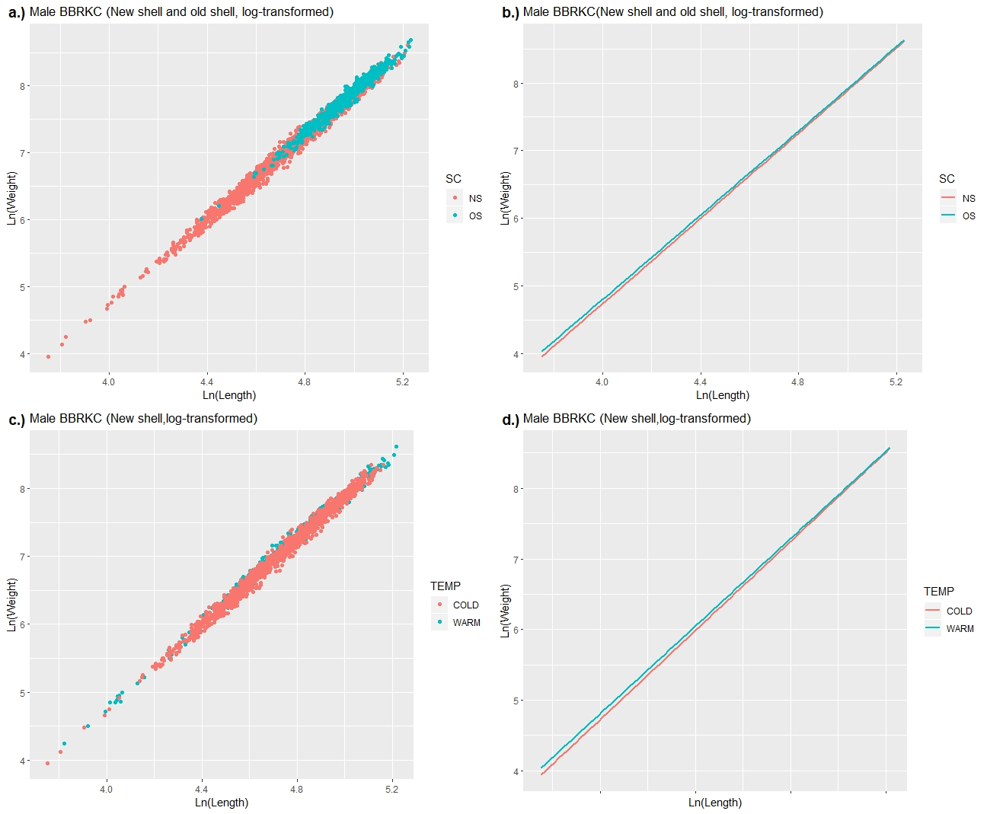

Figure 1. For Bristol Bay red king crab; a.) scatterplot of natural log transformed weights by natural log transformed carapace length measurements, with shell condition group indicated by color, b.) fitted linear model regression lines for shell condition groups, c.) scatterplot of natural log transformed weights by natural log transformed carapace length measurements, with survey year thermal regime indicated by color, d.) fitted linear model regression lines for thermal regime groups.

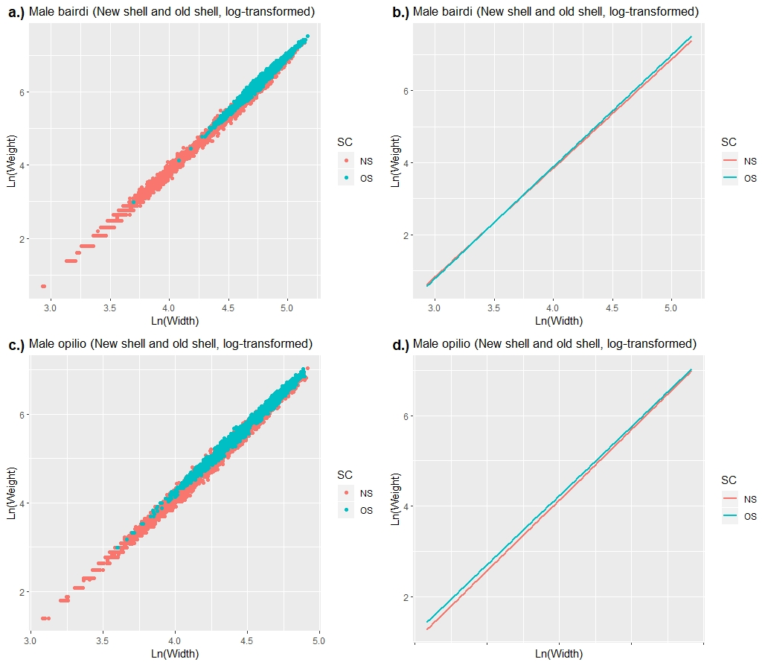

Figure 2. For Eastern Bering Sea Bairdi; a.) scatterplot of natural log transformed weights by natural log transformed carapace length measurements, with shell condition group indicated by color, b.) fitted linear model regression lines for shell condition group models. For Eastern Bering Sea opilio; c.) scatterplot of natural log transformed weights by natural log transformed carapace length measurements, with shell condition group indicated by color, d.) fitted linear model regression lines for shell condition group models.

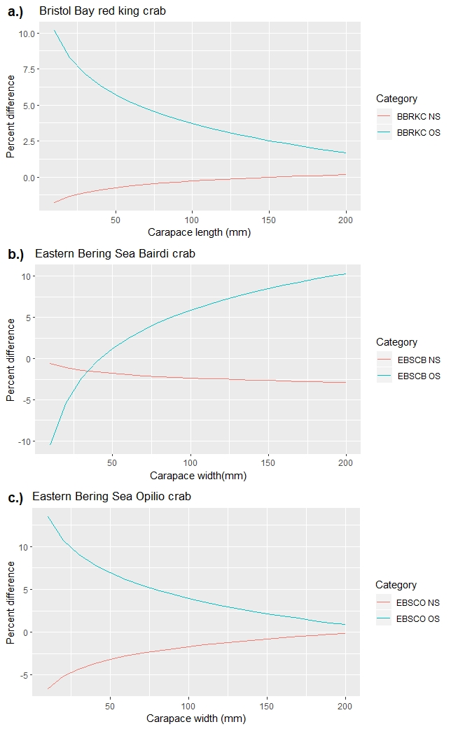

Figure 3. Percent difference in weight between shell condition specific size-weight model and current standard model by size for a.) Bristol Bay red king crab, b.) Eastern Bering Sea Bairdi crab and c.) Eastern Bering Sea opilio crab.

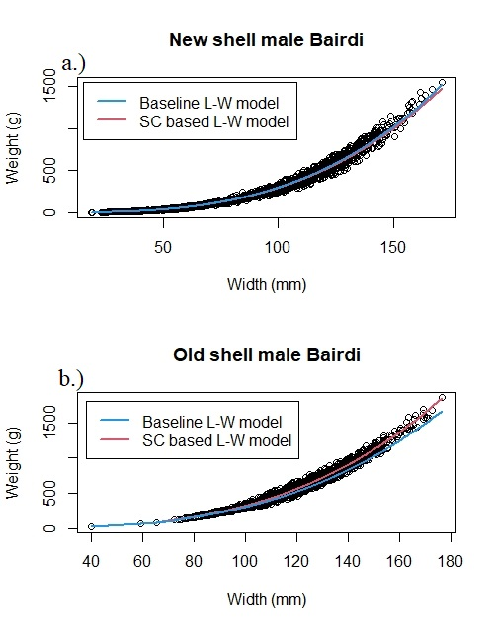

Figure 5. Comparison of baseline and bias-corrected, shell condition-based size-weight models for a.) new shell (NS) male bairdi and b.) old shell (OS) male bairdi. Note poor fit of baseline model to OS data, particularly at sizes >120 mm.

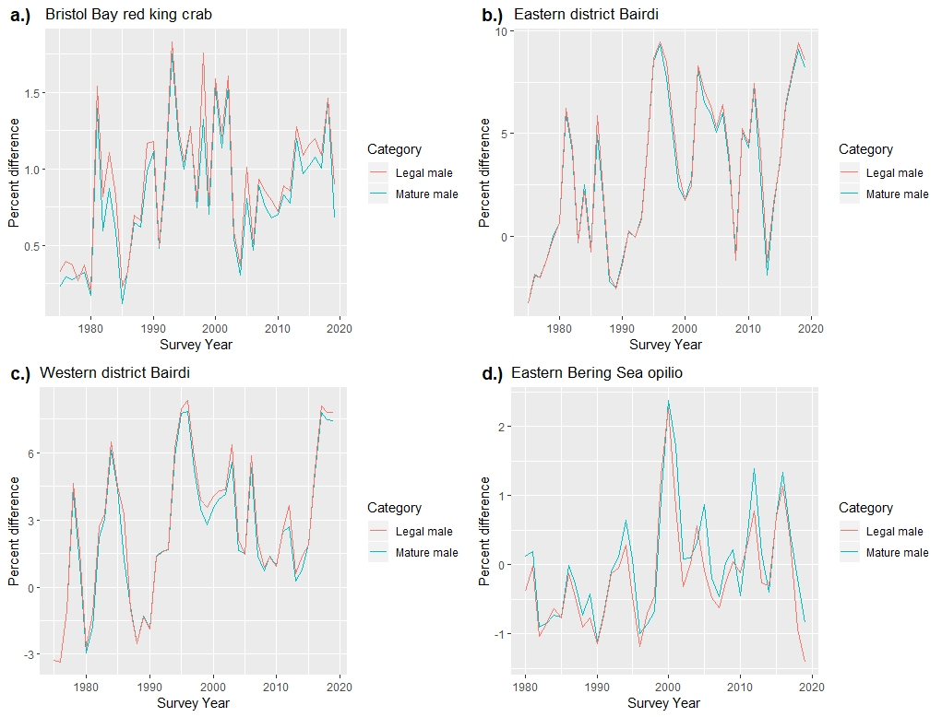

Figure 6. Percent difference in population biomass estimates for mature and legal to retain male size classes for; a.) Bristol Bay red king crab, b.) Eastern district Bairdi crab, c.) Western district bairdi crab and d.) Eastern Bering Sea opilio crab.